Test 1: Normal BMI, tests formula/inputs & outputs. Inputs: Weight 150, feet 5, inches 8, then n to end it. Output expected: BMI is 22.8 category is normal
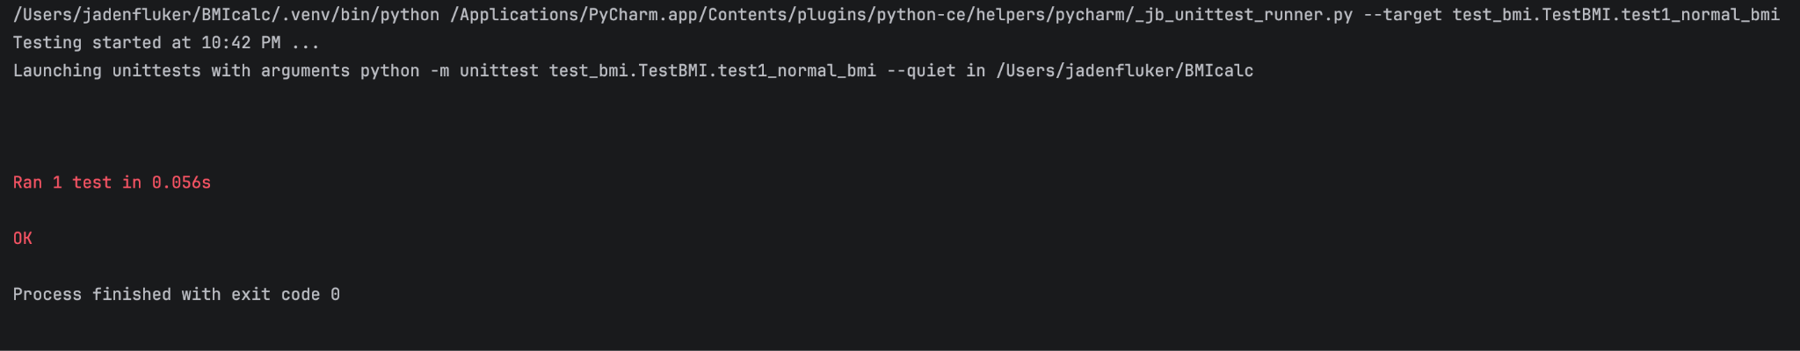
Test 2: Tests underweight BMI path. Inputs: Weight 100, feet 6, inches 0, n to end it. Output expected: BMI is 13.6 category is underweight
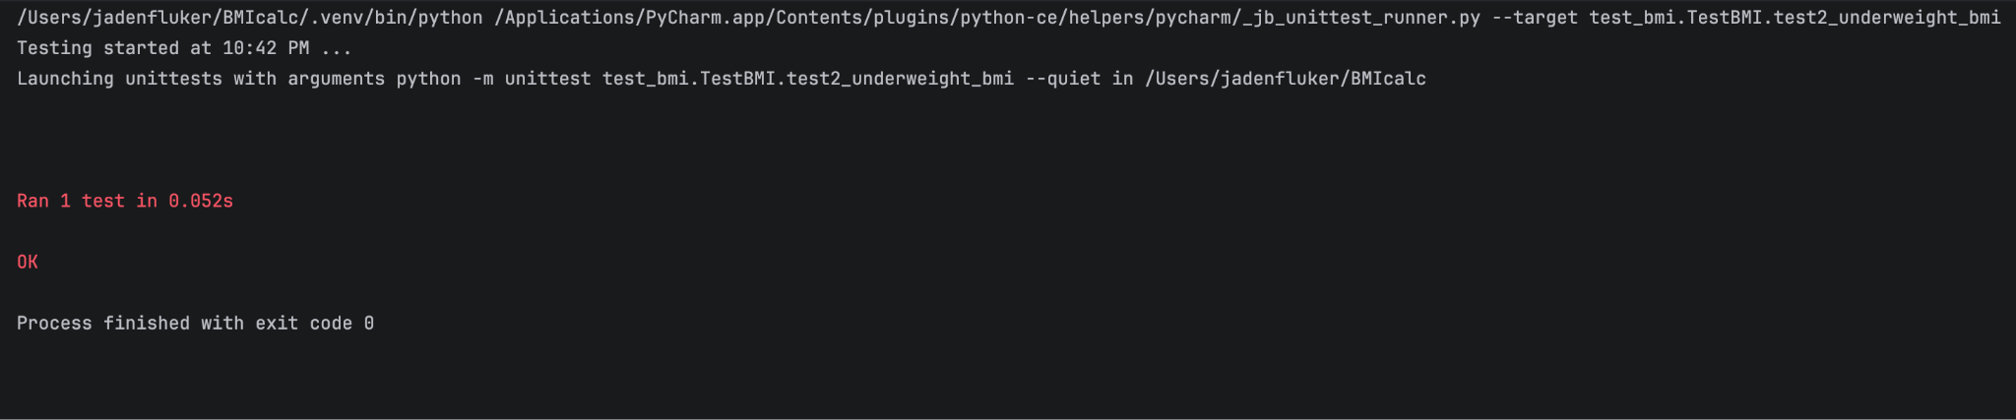
Test 3: Tests overweight path. Inputs: weight 180, feet 5, inches 8, n to end it. Output expected: BMI is 24.7 category is overweight 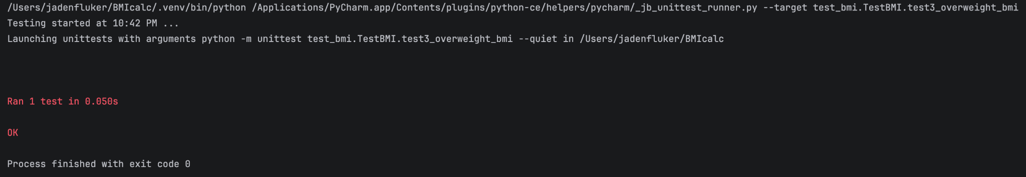
Test 4 Tests obese path. Inputs: weight 250, feet 5, inches 8, n to end it. Output expected: BMI is 38.0 category is obese
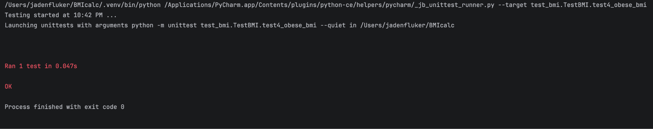
Test 5 Trying to force “abc” into a number category. Should print error message, not crash. Inputs: weight abc, then 150, 5, 8 and n to end it. Expected output: denies “abc” string and asks again. Then, BMI is 22.8 category is normal
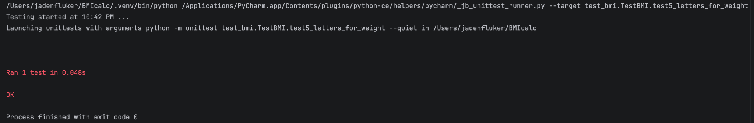
Test 6 Testing negative weight. Inputs: Weight -10, feet 5, inches 8 then 150, 5, 8, and n to end it. Expected output: Denies value below 0, asks again, then BMI is 22.8 category is normal.
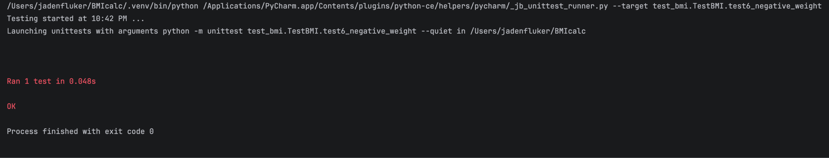
Test 7: Tries to force inches value over 11. Inputs: Weight 150, feet 5, inches 15, then 150, 5,8, and n to end it. Expected output: Denies value over 11, asks again then bmi is 22.8 category is normal.
